C1: Individual Reflection and Evaluation Report
Name: Cameron Haynes
Student ID: BI54LV
Module: CET257 Enterprise Project
Faculty of Business & Technology

Introduction
This report is here to outline my personal experience with CET 257 enterprise project as well as providing some evidence towards my contributions and how that shaped the project as a whole.
This project is based on the premise that we as a group are to form a small fictitious software company, in which our company has an online presence, in order to respond to or client brief. In this case our client was the Gateshead Health NHS Foundation Trust. Our brief was to create a piece of software in order to assist in the improvement of patients mental health, with it working alongside the NHS. In the team, which will be refereed to as our team name (MY software), I was Development Lead which means I was to architect the software solution and push forward the production of code. This lead to me designing the systems used for the solution as well as producing code for it.

Working through the project
I have never worked on software in a collaborative setting before this project meaning this was the first time for me I was putting to use knowledge I have learnt through the university course as well as outside it such as git and GitHub in a collaborative setting as well as an effective use of group programming paradigms which in this case is the Agile approach. We chose agile as it lends itself to a more modular web based solution very well especially in comparison to an approach such as the waterfall approach. This is not my first time working for a client however this is my first time working for a non-individual client so it required a very different set of skills of which I learnt through our interactions such as being able to interpret multiple ideas and how to be able to architect them. As well as this the requirements where a lot larger than I was used to from clients so learning how to engineer both a software and time efficient solution was a new angle to consider for me. This has overall lead me to being a more adaptable and flexible programmer, being able to adapt to new requests from multiple representatives.
As well as this I learnt how to build a technical solution in a group setting which changed my workflow as to get the best out of every person in the group I would also have to work around their needs and workflows which was a new and informative experience.
I am lucky to already be comfortable with the use of git and GitHub so that allowed me to focus on a lot of the team and client facing problems which for me were the biggest points to learn from.

Teamwork and Group Experience

Personal Performance Evaluation

Development Lifecycle Reflection

Employability and Skills Development

Conclusion

Evidence Of Personal Contributions

Figure 1: Article recommendation system flowchart
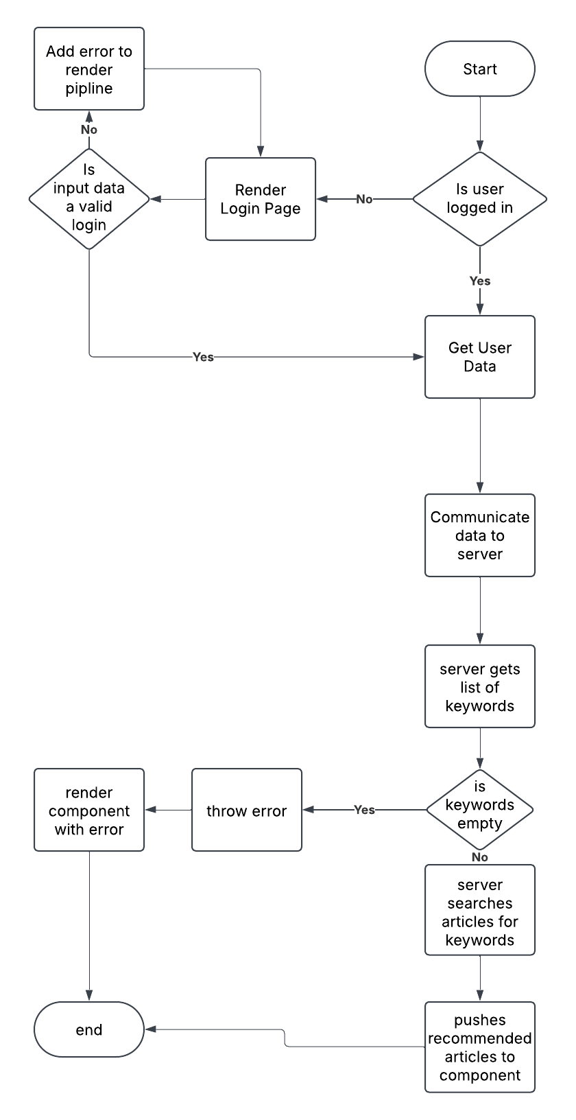

Figure 2: Profile Page Flowchart
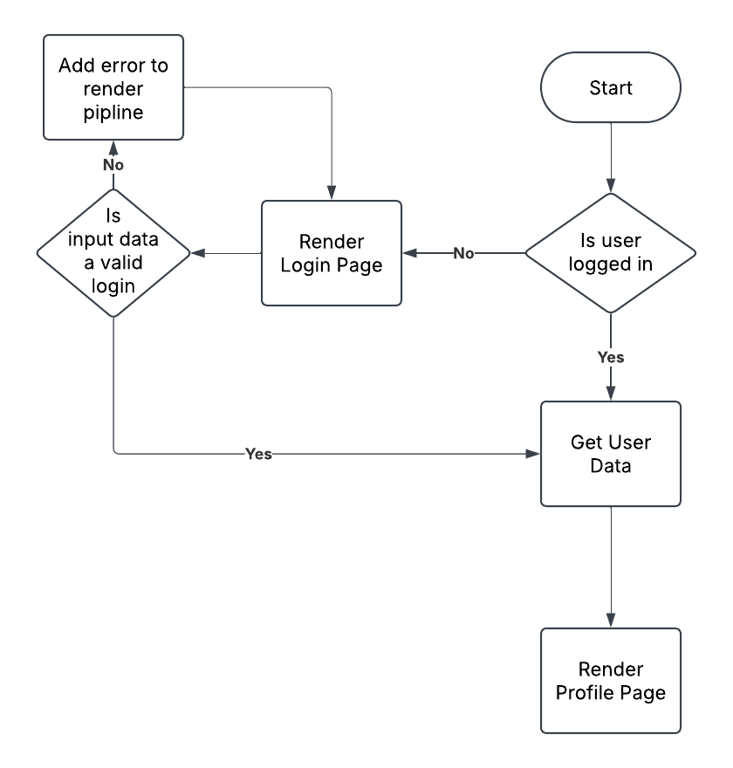

Figure 3: Database Entity Relationship Diagram
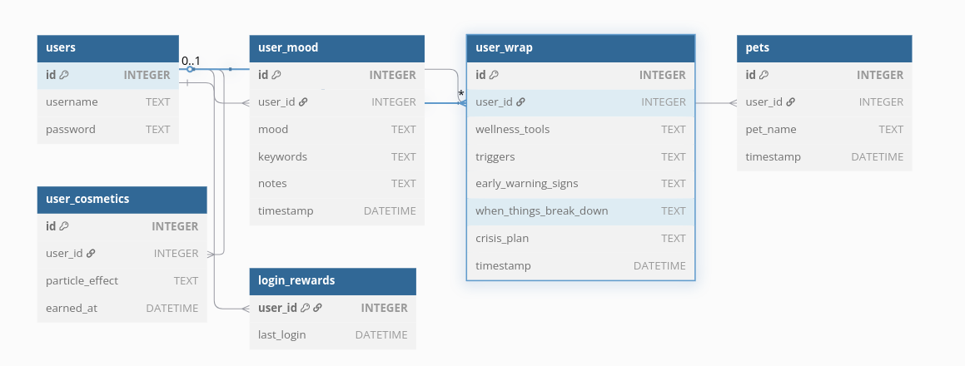
Figure 4: Agile Document

Project Overview
- Project Description: A web app that will have multiple pages , a mood tracking page which will allow users to select a mood on a scale , fill in keywords based on their mood as well as submit some notes, on this page they may get articles recommended to them based on submissions. The next page will be a tamogochi style game that allows users to care for a cat, feed , pet , etc.
- Client: NHS UK
- Project Manager: Jeremy
- Development Manager: Cameron
- Date: 28th January 2025 – 7th March 2025

Project Scope
- Objective:
  - To create an interactive tool for customers of NHS mental health services in Gateshead to use in order to improve and maintain a positive mental health. This tool should aid the NHS not attempt to replace it.
- Features & User Stories:
  - To be able to log mood in both a granular and non granular manner
  - To be given recommendation on NHS articles and resources based on my mood history
  - To be able to pet, feed and interact with the chosen being within the game
  - To be able to view my mood log
  - To be able to register , login and logout

Agile Methodology
- Agile Framework:
  - Agile / SCRUM
- Sprint Duration:
  - 1 week per sprint with Tuesdays and Saturdays being review / meeting
- Team Members:
  - All normal documented roles apply with Jeremy being the SCRUM master

User Stories
  - Title: App From The Perspective Of A Practitioner
  - As a GP / Therapist,
I want be able to reference patients to this recourse to assist me and the patient on maintaining a positive mental health
So that I can give them more effective care
  - Acceptance Criteria:
    - The website is inclusive to all (disabilities: eg deaf or blind )
    - Personalised experience
    - Easy / intuitive to use
  - Priority: [High]

  - Title: User System
  - As a end user,
I want be able to register , log in and log out
So that I can access the content of the site
  - Acceptance Criteria:
    - Users can register with a custom username and password
    - username and password are stored on the database
    - password is encrypted
    - users can login with their custom username and password combination
    - all data is attached to the “profile” based on the combination
  - Priority: [High]

Title: User Progress
  - As a end user,
I want to be able to access my previous progress
So that I can track my progress of my mental health
  - Acceptance Criteria:
    - Progress is stored effectively
    - Progress can be retrieved even after a logout
Priority: [High]

Technical Documentation
- System Architecture:
  - A React Frontend with a ExpressJS API with a sqllite database.
  - Frontend -POST→ API → Database (or vice versa)
Flow Charts
    - Login
    - Article Recommendation

- API Documentation:

POST /register
- Description: Register a new user by providing a username and password. The password is hashed before storing in the database.
- Request Body:
  - username (string): The user's chosen username.
  - password (string): The user's password.
- Responses:
  - 201 Created: If the user is successfully registered.
    - Example: { "message": "User registered successfully" }
  - 500 Internal Server Error: If an error occurs while hashing the password or saving the user to the database.
    - Example: { "error": "Hashing error" }

POST /login
- Description: Log in a user by verifying their username and password. Returns a JWT token if successful.
- Request Body:
  - username (string): The user's username.
  - password (string): The user's password.
- Responses:
  - 200 OK: If the login is successful, returns a JWT token.
    - Example: { "token": "<JWT_TOKEN>" }
  - 400 Bad Request: If the username does not exist or the password is incorrect.
    - Example: { "error": "Invalid username or password" }

GET /profile
- Description: Get the profile information of the logged-in user. Requires a valid JWT token.
- Headers:
  - Authorization (string): Bearer token containing the JWT.
- Responses:
  - 200 OK: If the token is valid, returns the user's profile data.
    - Example: { "message": "Welcome to your profile!", "user": { "id": 1, "username": "example" } }
  - 401 Unauthorized: If no token is provided.
    - Example: { "error": "Token required" }
  - 403 Forbidden: If the token is invalid or expired.
    - Example: { "error": "Invalid or expired token" }

Moods

GET /userMoods
- Description: Get the mood entries for the logged-in user. Requires a valid JWT token.
- Headers:
  - Authorization (string): Bearer token containing the JWT.
- Responses:
  - 200 OK: If the token is valid, returns the list of mood entries.
    - Example: { "moods": [{ "id": 1, "mood": "Happy", "keywords": "joy", "notes": "Feeling great!", "visible_to_gps": true }] }
  - 401 Unauthorized: If no token is provided.
    - Example: { "error": "Token required" }
  - 403 Forbidden: If the token is invalid or expired.
    - Example: { "error": "Invalid or expired token" }

POST /saveMood
- Description: Save a new mood entry for the logged-in user. Requires a valid JWT token.
- Request Body:
  - mood (string): The mood description (e.g., "Happy", "Sad").
  - keywords (string): Comma-separated keywords associated with the mood.
  - notes (string): Additional notes for the mood entry.
- Headers:
  - Authorization (string): Bearer token containing the JWT.
- Responses:
  - 201 Created: If the mood is saved successfully.
    - Example: { "message": "Mood saved successfully" }
  - 401 Unauthorized: If no token is provided.
    - Example: { "error": "Token required" }
  - 403 Forbidden: If the token is invalid or expired.
    - Example: { "error": "Invalid token" }

Articles

GET /recommendedArticles
- Description: Get a list of articles that match the provided keywords.
- Parameters:
  - keywords (string): A comma-separated list of keywords to search for in the articles.
- Responses:
  - 200 OK: If articles matching the keywords are found, returns the list of recommended articles.
    - Example: { "recommendedArticles": [{ "title": "Article 1", "content": "This is the article content..." }] }
  - 400 Bad Request: If no keywords are provided.
    - Example: { "error": "No keywords provided" }
  - 500 Internal Server Error: If there is an error reading the articles directory.
    - Example: { "error": "Failed to read articles directory" }
- Database Design:
  - ER Diagram
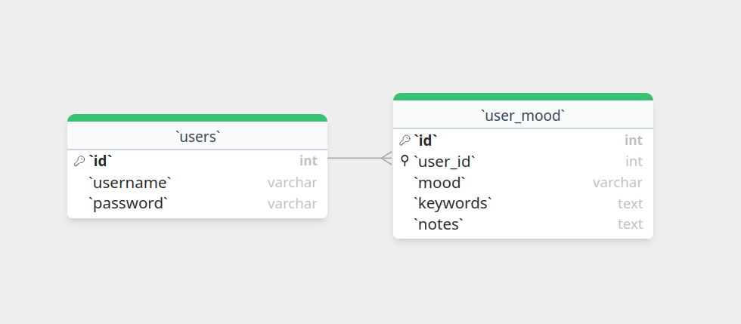
Data Dictionary
  - users
Field Name | Data Type | Description | Example | Constraints
id | INTEGER | A unique identifier for a user | 8 | Primary key,AUTOINCREMENT
username | TEXT | A username | “admin” | NOT NULL
password | TEXT | A password | “password” | NOT NULL

  - user_mood
Field Name | Data Type | Description | Example | Constraints
id | INTEGER | A unique identifier for the mood data | 5 | Primary Key,AUTOINCREMENT
user_id* | INTEGER |  |  | REFERENCES "users"("id")
mood | TEXT | A single word describing mood from slider | depressed | NOT NULL
keywords | TEXT | A list of keywords stored as a string (processed by server to) | “this,is,the,example” | NOT NULL
notes | TEXT | A chunk of text | Lorum ipsum

- Code Standards:
  - Function names in PascalCase.
  - Indentation is done via tab
  - Function signatures should be done using Kernighan and Ritchie style

Test Plan
- Types of Tests:
  - Unit testing using a testing framework for example testcafe
- Test Cases:
  - Any API endpoint failure such as 404 errors
  - API: Erroneous data, Correct data and bounds errors
  - Component rendering correctly

Risks & Mitigations
- Risk:
  - That information given by articles is either incorrect / not helpful or too vague
- Probability:
  - [Medium]
- Impact:
  - [High]
- Mitigation Plan:
  - We will only refer to the resources written by mental health professions by the NHS or the resources provided to us by the NHS for our articles
- Risk:
  - That user data is compromised
- Probability:
  - [High]
- Impact:
  - [High]
- Mitigation Plan:
  - We shall encrypt all data with a JWT key only known to the backend at the API level

Figure 5: Multiple Meeting Notes
Meeting 1 Notes
Our idea has to fall into the guidelines of a good tool but not a substitute for mental health support. We must assist the NHS not take it over.
App has to be reliable / robust and effective
Must be interaction by the whole of Gateshead (people who can read / write, hard of hearing / deaf , those who can speak english)
Must be accessible by all over the age of 16
NHS Gateshead mental health design colours NHS blue, purple, teal (https://www.gatesheadhealth.nhs.uk/services/mental-health/)
Refer to Becky to check if the use of our software is appropriate

Suggestions:
Reminder system / daily check in
Recommend articles based on keywords, personalised article recommendation (in article link to external resources)
Lead to help in crisis
To make the app more self lead instead of linking with GP
audio alternative
try to add pictures as a resume for written stuff
translation options??? (need to ask about the vast majority of languages to use)
to respond to the educational part they want us to add, maybe we can do a library that directs to nhs official pages
they want something durable, I think we can solve this automatically if our work is original enough

Meeting 1.5 Notes
Gateshead Peer Support Service Background:
Service To the Community
Lots of gaps in mental health service
For people who arent ready / dont need clinical therapy but want some help
in-between primary and secondary care
This service is for people who are registered to a gateshead gp

A non clinical approach
Mostly for accessing resources and more self learning
day to day health monitoring
if they need they can signpost themselfs using the app
non clinical and clinical articles
accessibility : can listen to articles as well as read
for ages 16 and up , reading age 8
2 sides to the app , Information/Signposting | Interactive
Meditation articles
Refer to apps such as Calm, they were referenced in meeting as good

Cat Ideas:
name cat
calm music in background

WRAP plan (wellness recovery action plan)
- use as a base for wellbeing forum

Meeting 2 Notes
WRAP plan phrasing changes need to be made (avoid the words crisis and triggers)
Daily maintenance can be added through game mechanics
Good that you can change animal, give more customisation
Add voice control
Dyslexic friendly font and colours need to be added
No place that had videos, relaxation, helpful links. Is a must add

Figure 6: Sprint 2 Review

Sprint 2
Planning
Goals for Sprint:
  - To create out identity and to start implementing the proposed changes from our meeting into the project
  - Get meeting notes from second talk with NHS representatives
- Stories for Sprint:
  - Create Final Logo
  - Start on design for corporate website

Stand-up
- Team Members Updates:
  - We had got to touch base with Heytham , Jermay and Cameron and we all managed to plan a lot through wireframes, flowcharts and face to face discussion.

8. Sprint Review
- Summary of Completed Stories:
  - Proposed changes are being implemented

9. Sprint Retrospective
- What went well?
  - The confirmation of our ideas from the NHS was lovely, development has started quickly
- What didn’t go well?
  - No further updates on brand identity
- Action Items for Next Sprint:
  - further updates on brand identity

Figure 7: Draft Email To Client
Subject: MY Software: NHS x Sunderland University Web App

Hello all, I hope you are doing well!

I'm reaching out to share this demo that the development team has put together to show our progress on the app, following up on our second meeting.
The demo video will be attached to this email.

If you would like any further resources, please follow up via email, and we will gladly send any details or sources over.
Any questions and/or comments are greatly appreciated.

Thank you very much for taking the time to read, watch, and respond to us.

All the best,
Cameron Haynes
Development Lead, MY Software

Figure 8: Commit History (at : https://github.com/CamH04/Enterprise-Project-Group-9)

 | kill | kill
e1341ae | CamH04 | Thu, 1 May 2025 11:40:37 +0100 | cosmetic changes |  | 10 files changed | 13389 insertions(+) | 5352 deletions(-)
56bd694 | CamH04 | Thu, 1 May 2025 10:58:46 +0100 | added api support for daily costmetics |  | 3 files changed | 53 insertions(+) | 7 deletions(-)
6b54216 | CamH04 | Wed, 30 Apr 2025 13:14:23 +0100 | sfsbdifbia |  | 1 file changed | 0 insertions(+) | 0 deletions(-)
10da772 | CamH04 | Wed, 30 Apr 2025 13:09:40 +0100 | added audio to reccomended |  | 2 files changed | 9 insertions(+) | 3 deletions(-)
a452285 | CamH04 | Wed, 30 Apr 2025 12:58:16 +0100 | client report done for now |  | 1 file changed | 0 insertions(+) | 0 deletions(-)
9b2d147 | CamH04 | Tue, 29 Apr 2025 15:11:44 +0100 | cir report |  | 2 files changed | 0 insertions(+) | 0 deletions(-)
59b72ac | CamH04 | Tue, 29 Apr 2025 15:02:00 +0100 | added final powerpoint |  | 4 files changed | 1 deletion(-)
46fafb6 | CamH04 | Tue, 29 Apr 2025 12:13:57 +0100 | general doc updates |  | 16 files changed | 12 insertions(+) | 4 deletions(-)
3c390c3 | CamH04 | Mon, 28 Apr 2025 11:44:47 +0100 | update readme |  | 2 files changed | 6 insertions(+) | 2 deletions(-)
14acdba | CamH04 | Mon, 28 Apr 2025 11:38:04 +0100 | added survey and new game build |  | 5 files changed | 29462 insertions(+) | 3783 deletions(-)
bc50f29 | CamH04 | Fri, 25 Apr 2025 03:51:13 +0100 | collapse hud button added, broken hud |  | 8 files changed | 491 insertions(+) | 24 deletions(-)
299102c | CamH04 | Tue, 22 Apr 2025 16:15:34 +0100 | can now name your pet |  | 6 files changed | 139 insertions(+) | 7 deletions(-)
413f461 | CamH04 | Tue, 22 Apr 2025 15:51:10 +0100 | added files |  | 104 files changed | 1611 insertions(+) | 3 deletions(-)
dcb0282 | CamH04 | Tue, 8 Apr 2025 16:18:59 +0100 | files added for pres |  | 4 files changed | 1 insertion(+) | 1 deletion(-)
e16582a | CamH04 | Thu, 3 Apr 2025 15:02:34 +0100 | home buttons work now :) |  | 5 files changed | 22 insertions(+) | 5 deletions(-)
eea0c14 | CamH04 | Tue, 1 Apr 2025 15:36:26 +0100 | adsasd |  | 1 file changed | 0 insertions(+) | 0 deletions(-)
91ad1f4 | garsidej2005 | Tue, 1 Apr 2025 15:15:20 +0100 | Add files via upload |  | 1 file changed | 15 insertions(+) | 14 deletions(-)
7ade3ef | garsidej2005 | Tue, 1 Apr 2025 15:13:50 +0100 | Add files via upload |  | 1 file changed | 3 insertions(+) | 10 deletions(-)
a2345ea | garsidej2005 | Tue, 1 Apr 2025 15:07:07 +0100 | Add files via upload |  | 6 files changed | 110 insertions(+) | 62 deletions(-)
27b226c | garsidej2005 | Mon, 31 Mar 2025 18:13:00 +0100 | Add files via upload |  | 2 files changed | 105 insertions(+) | 11 deletions(-)
5a15958 | CamH04 | Tue, 25 Mar 2025 15:47:57 +0000 | weekly update |  | 1 file changed | 0 insertions(+) | 0 deletions(-)
2552dfb | CamH04 | Tue, 25 Mar 2025 15:43:39 +0000 | NO BUILD dev updates to game |  | 343 files changed | 556439 insertions(+) | 4 deletions(-)
0d3f5f4 | garsidej2005 | Tue, 25 Mar 2025 15:38:03 +0000 | Delete Assignment1/A4 - Group Meeting Minutes |  | 1 file changed | 1 deletion(-)
479b687 | garsidej2005 | Tue, 25 Mar 2025 15:37:33 +0000 | Create A4 - Group Meeting Minutes |  | 1 file changed | 1 insertion(+)
5d9b875 | garsidej2005 | Tue, 25 Mar 2025 15:33:52 +0000 | Delete Assignment1/A4 - Group meeting minutes/Group Meeting Minutes.docx |  | 1 file changed | 0 insertions(+) | 0 deletions(-)
cd797b8 | garsidej2005 | Tue, 18 Mar 2025 15:28:26 +0000 | Uploading minutes |  | 1 file changed | 0 insertions(+) | 0 deletions(-)
7aea7da | CamH04 | Tue, 18 Mar 2025 15:12:53 +0000 | week 8 reflection |  | 1 file changed | 0 insertions(+) | 0 deletions(-)
4566cec | CamH04 | Tue, 18 Mar 2025 14:51:57 +0000 | bash script to start and some style changes |  | 9 files changed | 92 insertions(+) | 28 deletions(-)
f002eee | CamH04 | Thu, 13 Mar 2025 12:44:32 +0000 | forgot what i did |  | 3 files changed | 181 insertions(+) | 1 deletion(-)
4890e1d | CamH04 | Thu, 13 Mar 2025 12:31:47 +0000 | added the reset password system |  | 6 files changed | 106 insertions(+) | 10 deletions(-)
7e1ac63 | CamH04 | Thu, 13 Mar 2025 12:18:34 +0000 | update WRAP plan func |  | 3 files changed | 111 insertions(+) | 11 deletions(-)
7963539 | CamH04 | Wed, 12 Mar 2025 16:31:57 +0000 | added most recent game build |  | 1 file changed | 1 insertion(+)
cb0ba46 | CamH04 | Wed, 12 Mar 2025 16:23:09 +0000 | audio player |  | 8 files changed | 51 insertions(+) | 1 deletion(-)
7332df7 | garsidej2005 | Tue, 11 Mar 2025 14:15:59 +0000 | Pushing group minutes |  | 1 file changed | 0 insertions(+) | 0 deletions(-)
d4b672c | CamH04 | Tue, 11 Mar 2025 13:03:51 +0000 | started client email |  | 1 file changed | 15 insertions(+)
0 | CamH04 | Tue, 11 Mar 2025 12:55:45 +0000 | done weekly reflection |  | 1 file changed | 0 insertions(+) | 0 deletions(-)
636b296 | CamH04 | Tue, 11 Mar 2025 12:47:19 +0000 | added read aloud articles |  | 7 files changed | 812 insertions(+) | 9 deletions(-)
e50e2c0 | CamH04 | Tue, 11 Mar 2025 11:41:22 +0000 | WRAP css updates |  | 7 files changed | 90 insertions(+) | 10 deletions(-)
34d42f0 | Yoz-LG | Fri, 7 Mar 2025 17:12:05 +0000 | Add files via upload |  | 4bab910 | Yoz-LG | Fri, 7 Mar 2025 17:11:11 +0000 | Add files via upload |  | 1 file changed | 0 insertions(+) | 0 deletions(-)
 | 787eb80 | Yoz-LG | Fri, 7 Mar 2025 16:00:03 +0000 | Add files via upload |  | b26416e | Yoz-LG | Fri, 7 Mar 2025 15:59:25 +0000 | Add files via upload
1 file changed | 0 insertions(+) | 0 deletions(-) |  | 6ca70d9 | Walid Graihim | Fri, 7 Mar 2025 01:37:10 +0000 | Add promotional website screenshots for Task B1
8 files changed | 0 insertions(+) | 0 deletions(-) |  | 83fef4b | Walid Graihim | Fri, 7 Mar 2025 01:35:45 +0000 | Create README.md
1 file changed | 2 deletions(-) |  | 46db070 | Walid Graihim | Fri, 7 Mar 2025 01:35:10 +0000 | Update README.md
1 file changed | 22 insertions(+) | 2 deletions(-) |  | 50d6dc6 | Walid Graihim | Fri, 7 Mar 2025 01:29:00 +0000 | Create README.md
1 file changed | 3 insertions(+) |  | d1e554d | Walid Graihim | Fri, 7 Mar 2025 01:12:06 +0000 | Create B1_Website.md
1 file changed | 21 insertions(+) |  | fea5003 | zahamshah | Fri, 7 Mar 2025 00:13:50 +0000 | Add files via upload
1 file changed | 0 insertions(+) | 0 deletions(-) |  | af2d741 | zahamshah | Fri, 7 Mar 2025 00:13:08 +0000 | Delete Assignment1/A2 - Report on group roles, rules and group registration form/Skills Audit - Syed Zaham.docx
1 file changed | 0 insertions(+) | 0 deletions(-) |  | 938b83c | zahamshah | Fri, 7 Mar 2025 00:07:56 +0000 | Add files via upload
1 file changed | 0 insertions(+) | 0 deletions(-) |  | 4ed7799 | zahamshah | Thu, 6 Mar 2025 23:54:10 +0000 | Add files via upload
6 files changed | 0 insertions(+) | 0 deletions(-) |  | c281072 | zahamshah | Thu, 6 Mar 2025 23:50:20 +0000 | Delete Assignment1/A8 - Self and Peer Assessment /self reflections/ZahamDocs/week 4 - Zaham.docx
1 file changed | 0 insertions(+) | 0 deletions(-) |  | 6fa480c | zahamshah | Thu, 6 Mar 2025 23:50:13 +0000 | Delete Assignment1/A8 - Self and Peer Assessment /self reflections/ZahamDocs/week 3 - Zaham.docx
1 file changed | 0 insertions(+) | 0 deletions(-) |  | 6d94b06 | zahamshah | Thu, 6 Mar 2025 23:50:04 +0000 | Delete Assignment1/A8 - Self and Peer Assessment /self reflections/ZahamDocs/fill to say im here
1 file changed | 1 deletion(-) |  | 73bfc92 | zahamshah | Thu, 6 Mar 2025 23:49:51 +0000 | Delete Assignment1/A8 - Self and Peer Assessment /self reflections/ZahamDocs/week 2 zaham latest.docx
1 file changed | 0 insertions(+) | 0 deletions(-) |  | 6d9c3f2 | zahamshah | Thu, 6 Mar 2025 23:49:41 +0000 | Delete Assignment1/A8 - Self and Peer Assessment /self reflections/ZahamDocs/week 1 latest zaham.docx
1 file changed | 0 insertions(+) | 0 deletions(-) |  | be83204 | Walid Graihim | Thu, 6 Mar 2025 23:35:16 +0000 | Add files via upload
42b337a | Walid Graihim | Thu, 6 Mar 2025 23:34:09 +0000 | start of assignment B |  | 1 file changed | 0 insertions(+) | 0 deletions(-)
7cecf98 | CamH04 | Thu, 6 Mar 2025 12:06:22 +0000 | start of assignment B |  | 1823 files changed | 164955 insertions(+)
7504a0d | zahamshah | Wed, 5 Mar 2025 16:38:06 +0000 | Add files via upload |  | 1 file changed | 0 insertions(+) | 0 deletions(-)
90a47ed | CamH04 | Tue, 4 Mar 2025 17:43:11 +0000 | changes to frontend |  | 189 files changed | 358078 insertions(+) | 23 deletions(-)
f1be1df | garsidej2005 | Tue, 4 Mar 2025 16:43:00 +0000 | Uploading updated minutes |  | 1 file changed | 0 insertions(+) | 0 deletions(-)
ed60b73 | garsidej2005 | Tue, 4 Mar 2025 16:21:50 +0000 | Uploading updated documents |  | 1 file changed | 0 insertions(+) | 0 deletions(-)
0f78367 | garsidej2005 | Tue, 4 Mar 2025 15:07:21 +0000 | Uploading final things |  | 1 file changed | 0 insertions(+) | 0 deletions(-)
12966b4 | CamH04 | Tue, 4 Mar 2025 14:20:17 +0000 | designs added |  | 22 files changed | 1 insertion(+) | 11 deletions(-)
e5c4f66 | garsidej2005 | Tue, 4 Mar 2025 12:39:46 +0000 | Adding powerpoint presentation |  | 1 file changed | 0 insertions(+) | 0 deletions(-)
5089508 | CamH04 | Tue, 4 Mar 2025 12:34:20 +0000 | peer assesment |  | 2 files changed | 0 insertions(+) | 0 deletions(-)
79d84d1 | CamH04 | Tue, 4 Mar 2025 11:51:29 +0000 | changes o structure before meeting |  | 64 files changed | 1 deletion(-)
6f6b441 | CamH04 | Tue, 4 Mar 2025 11:13:13 +0000 | added raw crop website before meeting |  | 57 files changed | 19389 insertions(+)
78312ce | Walid Graihim | Mon, 3 Mar 2025 16:53:45 +0000 | Delete A6 - Corporate Identity Marketing strategy website design/website/site directory |  | 21 files changed | 17895 deletions(-)
f06c3c0 | Walid Graihim | Mon, 3 Mar 2025 16:53:00 +0000 | Delete A6 - Corporate Identity Marketing strategy website design/websiteA6/website.html |  | 1 file changed | 259 deletions(-)
6cf8f40 | Walid Graihim | Mon, 3 Mar 2025 16:52:37 +0000 | Create A6_Website_Design.md |  | 1 file changed | 12 insertions(+)
c1009ad | Walid Graihim | Mon, 3 Mar 2025 16:39:32 +0000 | Some of our work |  | 5 files changed | 0 insertions(+) | 0 deletions(-)
63fbd80 | Walid Graihim | Mon, 3 Mar 2025 16:32:14 +0000 | Final logo |  | 1 file changed | 0 insertions(+) | 0 deletions(-)
4e6c9bd | Walid Graihim | Mon, 3 Mar 2025 16:31:32 +0000 | Delete A6 - Corporate Identity Marketing strategy website design/logo art/new logo.png |  | 1 file changed | 0 insertions(+) | 0 deletions(-)
2b6bae1 | CamH04 | Thu, 27 Feb 2025 12:50:57 +0000 | readme changes |  | 1 file changed | 4 insertions(+) | 1 deletion(-)
4b20c9d | CamH04 | Thu, 27 Feb 2025 12:48:20 +0000 | small changes |  | 196 files changed | 84422 insertions(+) | 31 deletions(-)
4a8f960 | Walid Graihim | Wed, 26 Feb 2025 02:20:56 +0000 | Add files via upload |  | 1 file changed | 0 insertions(+) | 0 deletions(-)
3a9b5a7 | Walid Graihim | Wed, 26 Feb 2025 02:13:31 +0000 | Updated Marketing Strategy |  | 1 file changed | 0 insertions(+) | 0 deletions(-)
85bc4f9 | Walid Graihim | Wed, 26 Feb 2025 02:12:52 +0000 | Create x |  | 1 file changed | 1 insertion(+)
5925609 | Walid Graihim | Wed, 26 Feb 2025 02:12:25 +0000 | Delete A6 - Corporate Identity Marketing strategy website design/Strategy marketing 25-02.docx |  | 1 file changed | 0 insertions(+) | 0 deletions(-)
5fdc96d | Walid Graihim | Wed, 26 Feb 2025 02:07:46 +0000 | Delete A6 - Corporate Identity Marketing strategy website design/websiteA6/ar |  | 1 file changed | 1 deletion(-)
9eea7b0 | Walid Graihim | Wed, 26 Feb 2025 02:07:02 +0000 | Add files via upload |  | 1 file changed | 259 insertions(+)
baf4853 | Walid Graihim | Wed, 26 Feb 2025 02:06:42 +0000 | Create ar |  | 1 file changed | 1 insertion(+)
46b746c | Walid Graihim | Wed, 26 Feb 2025 02:05:58 +0000 | Delete A6 - Corporate Identity Marketing strategy website design/website/z |  | 1 file changed | 1 deletion(-)
8477580 | Walid Graihim | Wed, 26 Feb 2025 02:05:23 +0000 | Create z |  | 1 file changed | 1 insertion(+)
523ca07 | AgiosPaisios | Tue, 25 Feb 2025 16:15:21 +0000 | fix gramar error |  | 1 file changed | 0 insertions(+) | 0 deletions(-)
6fd589b | AgiosPaisios | Tue, 25 Feb 2025 16:13:36 +0000 | week5 update |  | 1 file changed | 0 insertions(+) | 0 deletions(-)
d9f744c | Walid Graihim | Tue, 25 Feb 2025 16:13:14 +0000 | Delete A6 - temporary marketing strategy |  | 1 file changed | 0 insertions(+) | 0 deletions(-)
f9a6ad4 | Walid Graihim | Tue, 25 Feb 2025 16:11:48 +0000 | Logo update into the marketing strategy |  | 1 file changed | 0 insertions(+) | 0 deletions(-)
a84f08b | zahamshah | Tue, 25 Feb 2025 15:16:57 +0000 | Add files via upload |  | 1 file changed | 0 insertions(+) | 0 deletions(-)
48cba12 | zahamshah | Tue, 25 Feb 2025 15:11:51 +0000 | Add files via upload |  | 1 file changed | 0 insertions(+) | 0 deletions(-)
fbd1e3c | zahamshah | Tue, 25 Feb 2025 15:11:38 +0000 | Delete A8 - Self and Peer Assessment /ZahamDocs/week 3 - Zaham.docx |  | 1 file changed | 0 insertions(+) | 0 deletions(-)
bf4ced8 | CamH04 | Tue, 25 Feb 2025 15:09:55 +0000 | pics to meeting2 |  | 26 files changed | 17895 insertions(+)
b4a363f | zahamshah | Tue, 25 Feb 2025 15:09:09 +0000 | Add files via upload |  | 1 file changed | 0 insertions(+) | 0 deletions(-)
80be52f | CamH04 | Tue, 25 Feb 2025 13:54:14 +0000 | figfiabi |  | 5 files changed | 6 insertions(+)
592420000000 | zahamshah | Tue, 25 Feb 2025 13:41:05 +0000 | Add files via upload |  | 1 file changed | 0 insertions(+) | 0 deletions(-)
77474fb | zahamshah | Tue, 25 Feb 2025 13:40:44 +0000 | Delete A2 - Report on group roles, rules and group registration form directory |  | 1 file changed | 0 insertions(+) | 0 deletions(-)
bfaf490 | zahamshah | Tue, 25 Feb 2025 13:40:34 +0000 | Add files via upload |  | 1 file changed | 0 insertions(+) | 0 deletions(-)
4350f14 | zahamshah | Tue, 25 Feb 2025 13:39:13 +0000 | Delete A2 - Report on group roles, rules and group registration form directory |  | 1 file changed | 0 insertions(+) | 0 deletions(-)
71038ff | zahamshah | Tue, 25 Feb 2025 13:38:40 +0000 | Add files via upload |  | 1 file changed | 0 insertions(+) | 0 deletions(-)
e803009 | zahamshah | Tue, 25 Feb 2025 13:32:56 +0000 | Delete A2 - Report on group roles, rules and group registration form /Skills Audit Latest Zaham.docx |  | 1 file changed | 0 insertions(+) | 0 deletions(-)
7f30556 | CamH04 | Tue, 25 Feb 2025 12:23:09 +0000 | bunch of stuff added today |  | 6 files changed | 40 insertions(+) | 1 deletion(-)
86feacb | CamH04 | Mon, 24 Feb 2025 11:33:51 +0000 | artiles parced |  | 111 files changed | 10818 insertions(+)
752772c | Walid Graihim | Sun, 23 Feb 2025 03:33:43 +0000 | Delete A8 - Self and Peer Assessment /WalidDocs/week2 directory |  | 1 file changed | 0 insertions(+) | 0 deletions(-)
1826912 | Walid Graihim | Sun, 23 Feb 2025 03:33:37 +0000 | Delete A8 - Self and Peer Assessment /WalidDocs/week1 directory |  | 1 file changed | 0 insertions(+) | 0 deletions(-)
4a7f7a1 | Walid Graihim | Sun, 23 Feb 2025 03:33:30 +0000 | Delete A8 - Self and Peer Assessment /WalidDocs/week3 directory |  | 1 file changed | 0 insertions(+) | 0 deletions(-)
dcc358b | Walid Graihim | Sun, 23 Feb 2025 03:33:11 +0000 | Add files via upload |  | 4 files changed | 0 insertions(+) | 0 deletions(-)
13d707e | Walid Graihim | Sun, 23 Feb 2025 03:27:22 +0000 | Delete A8 - Self and Peer Assessment /WalidDocs/week 4/w |  | 1 file changed | 1 deletion(-)
1ea3a01 | Walid Graihim | Sun, 23 Feb 2025 03:27:11 +0000 | Create w |  | 1 file changed | 1 insertion(+)
688743a | CamH04 | Wed, 19 Feb 2025 21:10:07 +0000 | sprint reveiw and todo updates |  | 2 files changed | 0 insertions(+) | 0 deletions(-)
0be7d7c | CamH04 | Wed, 19 Feb 2025 21:01:50 +0000 | some cnages , sorry for awful commit mssg |  | 11 files changed | 153 insertions(+) | 44 deletions(-)
f6c3b2f | CamH04 | Wed, 19 Feb 2025 15:29:07 +0000 | notes from eeting |  | 2 files changed | 26 insertions(+)
d8b22b4 | CamH04 | Tue, 18 Feb 2025 15:21:22 +0000 | changing file locations as recommended by becky |  | 15 files changed | 10 insertions(+) | 1 deletion(-)
f63a32b | garsidej2005 | Tue, 18 Feb 2025 15:08:11 +0000 | Pushing week 4 objectives |  | 1 file changed | 0 insertions(+) | 0 deletions(-)
64db5b5 | garsidej2005 | Tue, 18 Feb 2025 14:56:32 +0000 | Uploading initial website design |  | 1 file changed | 0 insertions(+) | 0 deletions(-)
4795f20 | CamH04 | Mon, 17 Feb 2025 23:19:56 +0000 | agile doc and docparcer |  | 5 files changed | 91 insertions(+)
f449c49 | zahamshah | Mon, 17 Feb 2025 18:04:45 +0000 | Add files via upload |  | 3 files changed | 0 insertions(+) | 0 deletions(-)
79f4f5b | CamH04 | Sun, 16 Feb 2025 17:43:04 +0000 | reccomendation logic updates |  | 18 files changed | 676 insertions(+) | 71 deletions(-)
af81b6b | Walid Graihim | Fri, 14 Feb 2025 23:02:07 +0000 | Final Version of Task A6 - Marketing Strategy Document. |  | 1 file changed | 0 insertions(+) | 0 deletions(-)
30b2f41 | Walid Graihim | Fri, 14 Feb 2025 23:00:40 +0000 | Delete A6 - Corporate Identity Marketing strategy website design/Strategy marketing A6 f.docx |  | 1 file changed | 0 insertions(+) | 0 deletions(-)
9ed6149 | Walid Graihim | Fri, 14 Feb 2025 22:24:36 +0000 | Final Version of Task A6 - Marketing Strategy Document |  | 1 file changed | 0 insertions(+) | 0 deletions(-)
e27eb12 | Walid Graihim | Fri, 14 Feb 2025 22:24:05 +0000 | Delete A6 - Corporate Identity Marketing strategy website design/Strategy marketing A6 f.docx |  | 1 file changed | 0 insertions(+) | 0 deletions(-)
582ea27 | CamH04 | Fri, 14 Feb 2025 21:56:32 +0000 | api docs |  | 3 files changed | 0 insertions(+) | 0 deletions(-)
b9b947f | CamH04 | Fri, 14 Feb 2025 20:03:58 +0000 | article rec system built: keyowrds |  | 13 files changed | 251 insertions(+) | 24 deletions(-)
587ec0a | CamH04 | Fri, 14 Feb 2025 19:10:34 +0000 | more agile doc stuff done |  | 3 files changed | 1 insertion(+)
6a332af | Walid Graihim | Fri, 14 Feb 2025 13:52:41 +0000 | Delete A6 - Corporate Identity Marketing strategy website design/Strategy marketing A6.docx |  | 1 file changed | 0 insertions(+) | 0 deletions(-)
db6344e | Walid Graihim | Fri, 14 Feb 2025 13:51:54 +0000 | Add files via upload |  | 1 file changed | 0 insertions(+) | 0 deletions(-)
588e804 | CamH04 | Wed, 12 Feb 2025 19:44:02 +0000 | designs |  | 4 files changed | 0 insertions(+) | 0 deletions(-)
ee1ec8a | CamH04 | Wed, 12 Feb 2025 14:43:28 +0000 | updating agile doc |  | 2 files changed | 8 deletions(-)
1ed0ac6 | CamH04 | Wed, 12 Feb 2025 14:02:16 +0000 | post meeting note collation and planning |  | 7 files changed | 7 insertions(+) | 6 deletions(-)
437f8e7 | Walid Graihim | Wed, 12 Feb 2025 00:30:48 +0000 | Delete A8 - Self and Peer Assessment /WalidDocs/week3/x |  | 1 file changed | 1 deletion(-)
819a22e | Walid Graihim | Wed, 12 Feb 2025 00:30:25 +0000 | Add files via upload |  | 1 file changed | 0 insertions(+) | 0 deletions(-)
2ec5411 | Walid Graihim | Wed, 12 Feb 2025 00:30:12 +0000 | Create x |  | 1 file changed | 1 insertion(+)
9e41dcc | Walid Graihim | Wed, 12 Feb 2025 00:29:48 +0000 | Delete A8 - Self and Peer Assessment /WalidDocs/week3/week 3.docx |  | 1 file changed | 0 insertions(+) | 0 deletions(-)
b4d378d | zahamshah | Tue, 11 Feb 2025 23:40:42 +0000 | Delete A8 - Self and Peer Assessment /ZahamDocs/Skills Audit Zaham.docx |  | 1 file changed | 0 insertions(+) | 0 deletions(-)
6294b86 | zahamshah | Tue, 11 Feb 2025 23:40:06 +0000 | Delete A8 - Self and Peer Assessment /ZahamDocs/week 2.docx |  | 1 file changed | 0 insertions(+) | 0 deletions(-)
205de8b | zahamshah | Tue, 11 Feb 2025 23:39:50 +0000 | Delete A8 - Self and Peer Assessment /ZahamDocs/week 1.docx |  | 1 file changed | 0 insertions(+) | 0 deletions(-)
3980f96 | Walid Graihim | Tue, 11 Feb 2025 23:19:31 +0000 | Delete A8 - Self and Peer Assessment /WalidDocs/week3/we |  | 1 file changed | 1 deletion(-)
cbc2bf1 | Walid Graihim | Tue, 11 Feb 2025 23:19:07 +0000 | Add files via upload |  | 1 file changed | 0 insertions(+) | 0 deletions(-)
7cf99d7 | Walid Graihim | Tue, 11 Feb 2025 23:18:42 +0000 | Create we |  | 1 file changed | 1 insertion(+)
67cadb6 | Walid Graihim | Tue, 11 Feb 2025 23:18:27 +0000 | Delete A8 - Self and Peer Assessment /WalidDocs/week3 |  | 1 file changed | 1 deletion(-)
5f623bb | Walid Graihim | Tue, 11 Feb 2025 23:12:31 +0000 | Create week3 |  | 1 file changed | 1 insertion(+)
7e5354b | AgiosPaisios | Tue, 11 Feb 2025 16:07:46 +0000 | Week 3 Update |  | 1 file changed | 0 insertions(+) | 0 deletions(-)
b531c52 | CamH04 | Tue, 11 Feb 2025 15:36:38 +0000 | notes added from client |  | 9 files changed | 12 insertions(+)
5bbdef8 | zahamshah | Tue, 11 Feb 2025 13:36:56 +0000 | Add files via upload |  | 3 files changed | 0 insertions(+) | 0 deletions(-)
89cfa74 | CamH04 | Tue, 11 Feb 2025 12:42:08 +0000 | added stuff to do doc for PM |  | 1 file changed | 0 insertions(+) | 0 deletions(-)
6f0f3f0 | CamH04 | Tue, 11 Feb 2025 11:16:00 +0000 | presentation before meet finalised gl |  | 6 files changed | 0 insertions(+) | 0 deletions(-)
f205151 | CamH04 | Sun, 9 Feb 2025 18:26:52 +0000 | PACT anylsis , prototype for mood page |  | 444 files changed | 331 insertions(+) | 150 deletions(-)
8df30a5 | Walid Graihim | Sat, 8 Feb 2025 21:15:07 +0000 | Delete A8 - Self and Peer Assessment /WalidDocs/week2/week2 |  | 1 file changed | 1 deletion(-)
b40fc51 | Walid Graihim | Sat, 8 Feb 2025 21:14:15 +0000 | Add files via upload |  | 1 file changed | 0 insertions(+) | 0 deletions(-)
cd1f957 | Walid Graihim | Sat, 8 Feb 2025 21:10:09 +0000 | Delete A8 - Self and Peer Assessment /WalidDocs/fill to say im here |  | 1 file changed | 1 deletion(-)
b9b4a29 | Walid Graihim | Sat, 8 Feb 2025 21:09:45 +0000 | Add files via upload |  | 1 file changed | 0 insertions(+) | 0 deletions(-)
cca40d5 | Walid Graihim | Sat, 8 Feb 2025 20:18:56 +0000 | Create week2 |  | 1 file changed | 1 insertion(+)
1a7c224 | Walid Graihim | Sat, 8 Feb 2025 20:18:12 +0000 | Delete A8 - Self and Peer Assessment /WalidDocs/week1/Individual Weekly Reflection Template Walid.docx |  | 1 file changed | 1 deletion(-)
033c41c | Walid Graihim | Sat, 8 Feb 2025 19:43:45 +0000 | Individual Weekly Reflection Template Walid.docx |  | 1 file changed | 0 insertions(+) | 0 deletions(-)
50e5368 | Walid Graihim | Sat, 8 Feb 2025 19:43:28 +0000 | Create Individual Weekly Reflection Template Walid.docx |  | 1 file changed | 1 insertion(+)
b1c3698 | Walid Graihim | Sat, 8 Feb 2025 19:42:41 +0000 | Delete A8 - Self and Peer Assessment /WalidDocs/week1/week 1.docx |  | 1 file changed | 0 insertions(+) | 0 deletions(-)
ba70fa8 | Walid Graihim | Sat, 8 Feb 2025 19:39:39 +0000 | Delete A8 - Self and Peer Assessment /WalidDocs/week1/Individual Weekly Reflection Template Walid.docx |  | 1 file changed | 1 deletion(-)
3e9af3f | Walid Graihim | Sat, 8 Feb 2025 19:39:15 +0000 | Individual Weekly Reflection Template Walid.docx |  | 1 file changed | 0 insertions(+) | 0 deletions(-)
54c7833 | Walid Graihim | Sat, 8 Feb 2025 19:39:02 +0000 | Delete A8 - Self and Peer Assessment /WalidDocs/week1/week 1.docx |  | 1 file changed | 0 insertions(+) | 0 deletions(-)
adde7e1 | Walid Graihim | Sat, 8 Feb 2025 19:38:04 +0000 | Add files via upload |  | 1 file changed | 0 insertions(+) | 0 deletions(-)
e0dbf27 | Walid Graihim | Sat, 8 Feb 2025 19:31:09 +0000 | Create Individual Weekly Reflection Template Walid.docx |  | 1 file changed | 1 insertion(+)
2512fcf | garsidej2005 | Sat, 8 Feb 2025 15:54:33 +0000 | Updated ppt with small changes |  | 1 file changed | 0 insertions(+) | 0 deletions(-)
30bfdf5 | Walid Graihim | Fri, 7 Feb 2025 13:12:07 +0000 | Delete A3 - Evidence of interaction with clients/meeting with the client.pptx |  | 1 file changed | 0 insertions(+) | 0 deletions(-)
27a5f70 | Walid Graihim | Fri, 7 Feb 2025 13:11:33 +0000 | Add files via upload |  | 1 file changed | 0 insertions(+) | 0 deletions(-)
84e3f88 | Walid Graihim | Fri, 7 Feb 2025 13:06:23 +0000 | Add files via upload |  | 1 file changed | 0 insertions(+) | 0 deletions(-)
9cc403d | Walid Graihim | Thu, 6 Feb 2025 20:30:20 +0000 | Added Marketing Strategy document for Task A6. |  | 1 file changed | 0 insertions(+) | 0 deletions(-)
bec9345 | Walid Graihim | Thu, 6 Feb 2025 20:24:40 +0000 | Delete A6 - Corporate Identity Marketing strategy website design directory |  | 1 file changed | 0 insertions(+) | 0 deletions(-)
48c1014 | Walid Graihim | Thu, 6 Feb 2025 20:22:50 +0000 | Add files via upload |  | 1 file changed | 0 insertions(+) | 0 deletions(-)
d83e38d | Walid Graihim | Thu, 6 Feb 2025 20:22:25 +0000 | Delete A6 - Corporate Identity Marketing strategy website design directory |  | 1 file changed | 0 insertions(+) | 0 deletions(-)
6672a5a | Walid Graihim | Thu, 6 Feb 2025 20:21:32 +0000 | Add files via upload |  | 1 file changed | 0 insertions(+) | 0 deletions(-)
9bc010c | CamH04 | Thu, 6 Feb 2025 12:27:17 +0000 | now agile docs |  | 2 files changed | 0 insertions(+) | 0 deletions(-)
0a3b56d | CamH04 | Thu, 6 Feb 2025 11:49:09 +0000 | group roles doc |  | 5 files changed | 10 deletions(-)
006d658 | CamH04 | Wed, 5 Feb 2025 14:28:12 +0000 | more |  | 4 files changed | 2 insertions(+)
85d6ba6 | CamH04 | Wed, 5 Feb 2025 13:32:47 +0000 | PACT - People |  | 6 files changed | 1 deletion(-)
85edcf3 | CamH04 | Wed, 5 Feb 2025 13:03:53 +0000 | changed file strcutre to one req by rubric |  | 657 files changed | 61 insertions(+) | 10706 deletions(-)
82d57cc | CamH04 | Wed, 5 Feb 2025 11:44:32 +0000 | continued powerpoint |  | 1 file changed | 1 deletion(-)
517ad78 | CamH04 | Wed, 5 Feb 2025 11:44:19 +0000 | continued powerpoint |  | 6 files changed | 1 insertion(+)
4b50743 | AgiosPaisios | Tue, 4 Feb 2025 21:35:32 +0000 | minutes updated for week2 |  | 1 file changed | 0 insertions(+) | 0 deletions(-)
cef4d4c | CamH04 | Tue, 4 Feb 2025 16:49:51 +0000 | powerpoint added |  | 1 file changed | 0 insertions(+) | 0 deletions(-)
609160 | CamH04 | Tue, 4 Feb 2025 16:49:01 +0000 | powerpoint added |  | 3 files changed | 1 insertion(+) | 1 deletion(-)
2647526 | garsidej2005 | Tue, 4 Feb 2025 15:13:32 +0000 | 2 |  | 1 file changed | 0 insertions(+) | 0 deletions(-)
03d35ee | CamH04 | Tue, 4 Feb 2025 14:56:04 +0000 | login system and footer |  | 19 files changed | 6784 insertions(+) | 16 deletions(-)
0c518bb | garsidej2005 | Tue, 4 Feb 2025 13:58:18 +0000 | Adding raw logo file |  | 1 file changed | 0 insertions(+) | 0 deletions(-)
0d7cac6 | garsidej2005 | Tue, 4 Feb 2025 13:35:33 +0000 | Pushing Week 2 Objective docs file |  | 1 file changed | 0 insertions(+) | 0 deletions(-)
4ef2655 | garsidej2005 | Tue, 4 Feb 2025 13:31:34 +0000 | Pushing Transparent Logo |  | 32030c9 | garsidej2005 | Tue, 4 Feb 2025 13:31:13 +0000 | Art logo |  | 1 file changed | 0 insertions(+) | 0 deletions(-)
 | 4e61cc6 | CamH04 | Thu, 30 Jan 2025 15:55:13 +0000 | started nav bar development using nhs cdn |  | 405 files changed | 134 insertions(+) | 50 deletions(-)
 | f5cc133 | garsidej2005 | Thu, 30 Jan 2025 14:20:21 +0000 | Adding Jeremy's personal documents |  | 2 files changed | 0 insertions(+) | 0 deletions(-)
 | d697c97 | CamH04 | Thu, 30 Jan 2025 13:40:09 +0000 | req questions and docs |  | 400 files changed | 44986 insertions(+) | 3 deletions(-)
 | 43b50ab | CamH04 | Thu, 30 Jan 2025 12:36:33 +0000 | wireframes |  | 1 file changed | 0 insertions(+) | 0 deletions(-)
 | 0e8601f | CamH04 | Thu, 30 Jan 2025 11:25:44 +0000 | started dev docs |  | 56 files changed | 18 insertions(+)
 | 0ed6a92 | AgiosPaisios | Tue, 28 Jan 2025 18:16:03 +0000 | Added all the members |  | 1 file changed | 0 insertions(+) | 0 deletions(-)
 | 3058d0e | AgiosPaisios | Tue, 28 Jan 2025 16:57:09 +0000 | Add Week 1 Minutes doc |  | 1 file changed | 0 insertions(+) | 0 deletions(-)
 | 1a2ea84 | CamH04 | Tue, 28 Jan 2025 16:11:51 +0000 | more doc changes |  | 9 files changed | 2 insertions(+) | 9 deletions(-)
 | e9a9b5d | Walid Graihim | Tue, 28 Jan 2025 15:25:29 +0000 | Create fill to say im here |  | 1 file changed | 1 insertion(+)
 | a69d531 | AgiosPaisios | Tue, 28 Jan 2025 14:47:59 +0000 | Update fill to say im here |  | 1 file changed | 1 insertion(+) | 1 deletion(-)
 | b5632b6 | CamH04 | Tue, 28 Jan 2025 14:37:20 +0000 | adding other dirs |  | 2 files changed | 2 insertions(+)
 | 0fdaa1d | CamH04 | Tue, 28 Jan 2025 14:33:01 +0000 | init commit |  | 1 file changed | 23 insertions(+)
 | 6f1cec0 | CamH04 | Tue, 28 Jan 2025 14:29:11 +0000 | init commit day 1 |  | 171 files changed | 25813 insertions(+)

